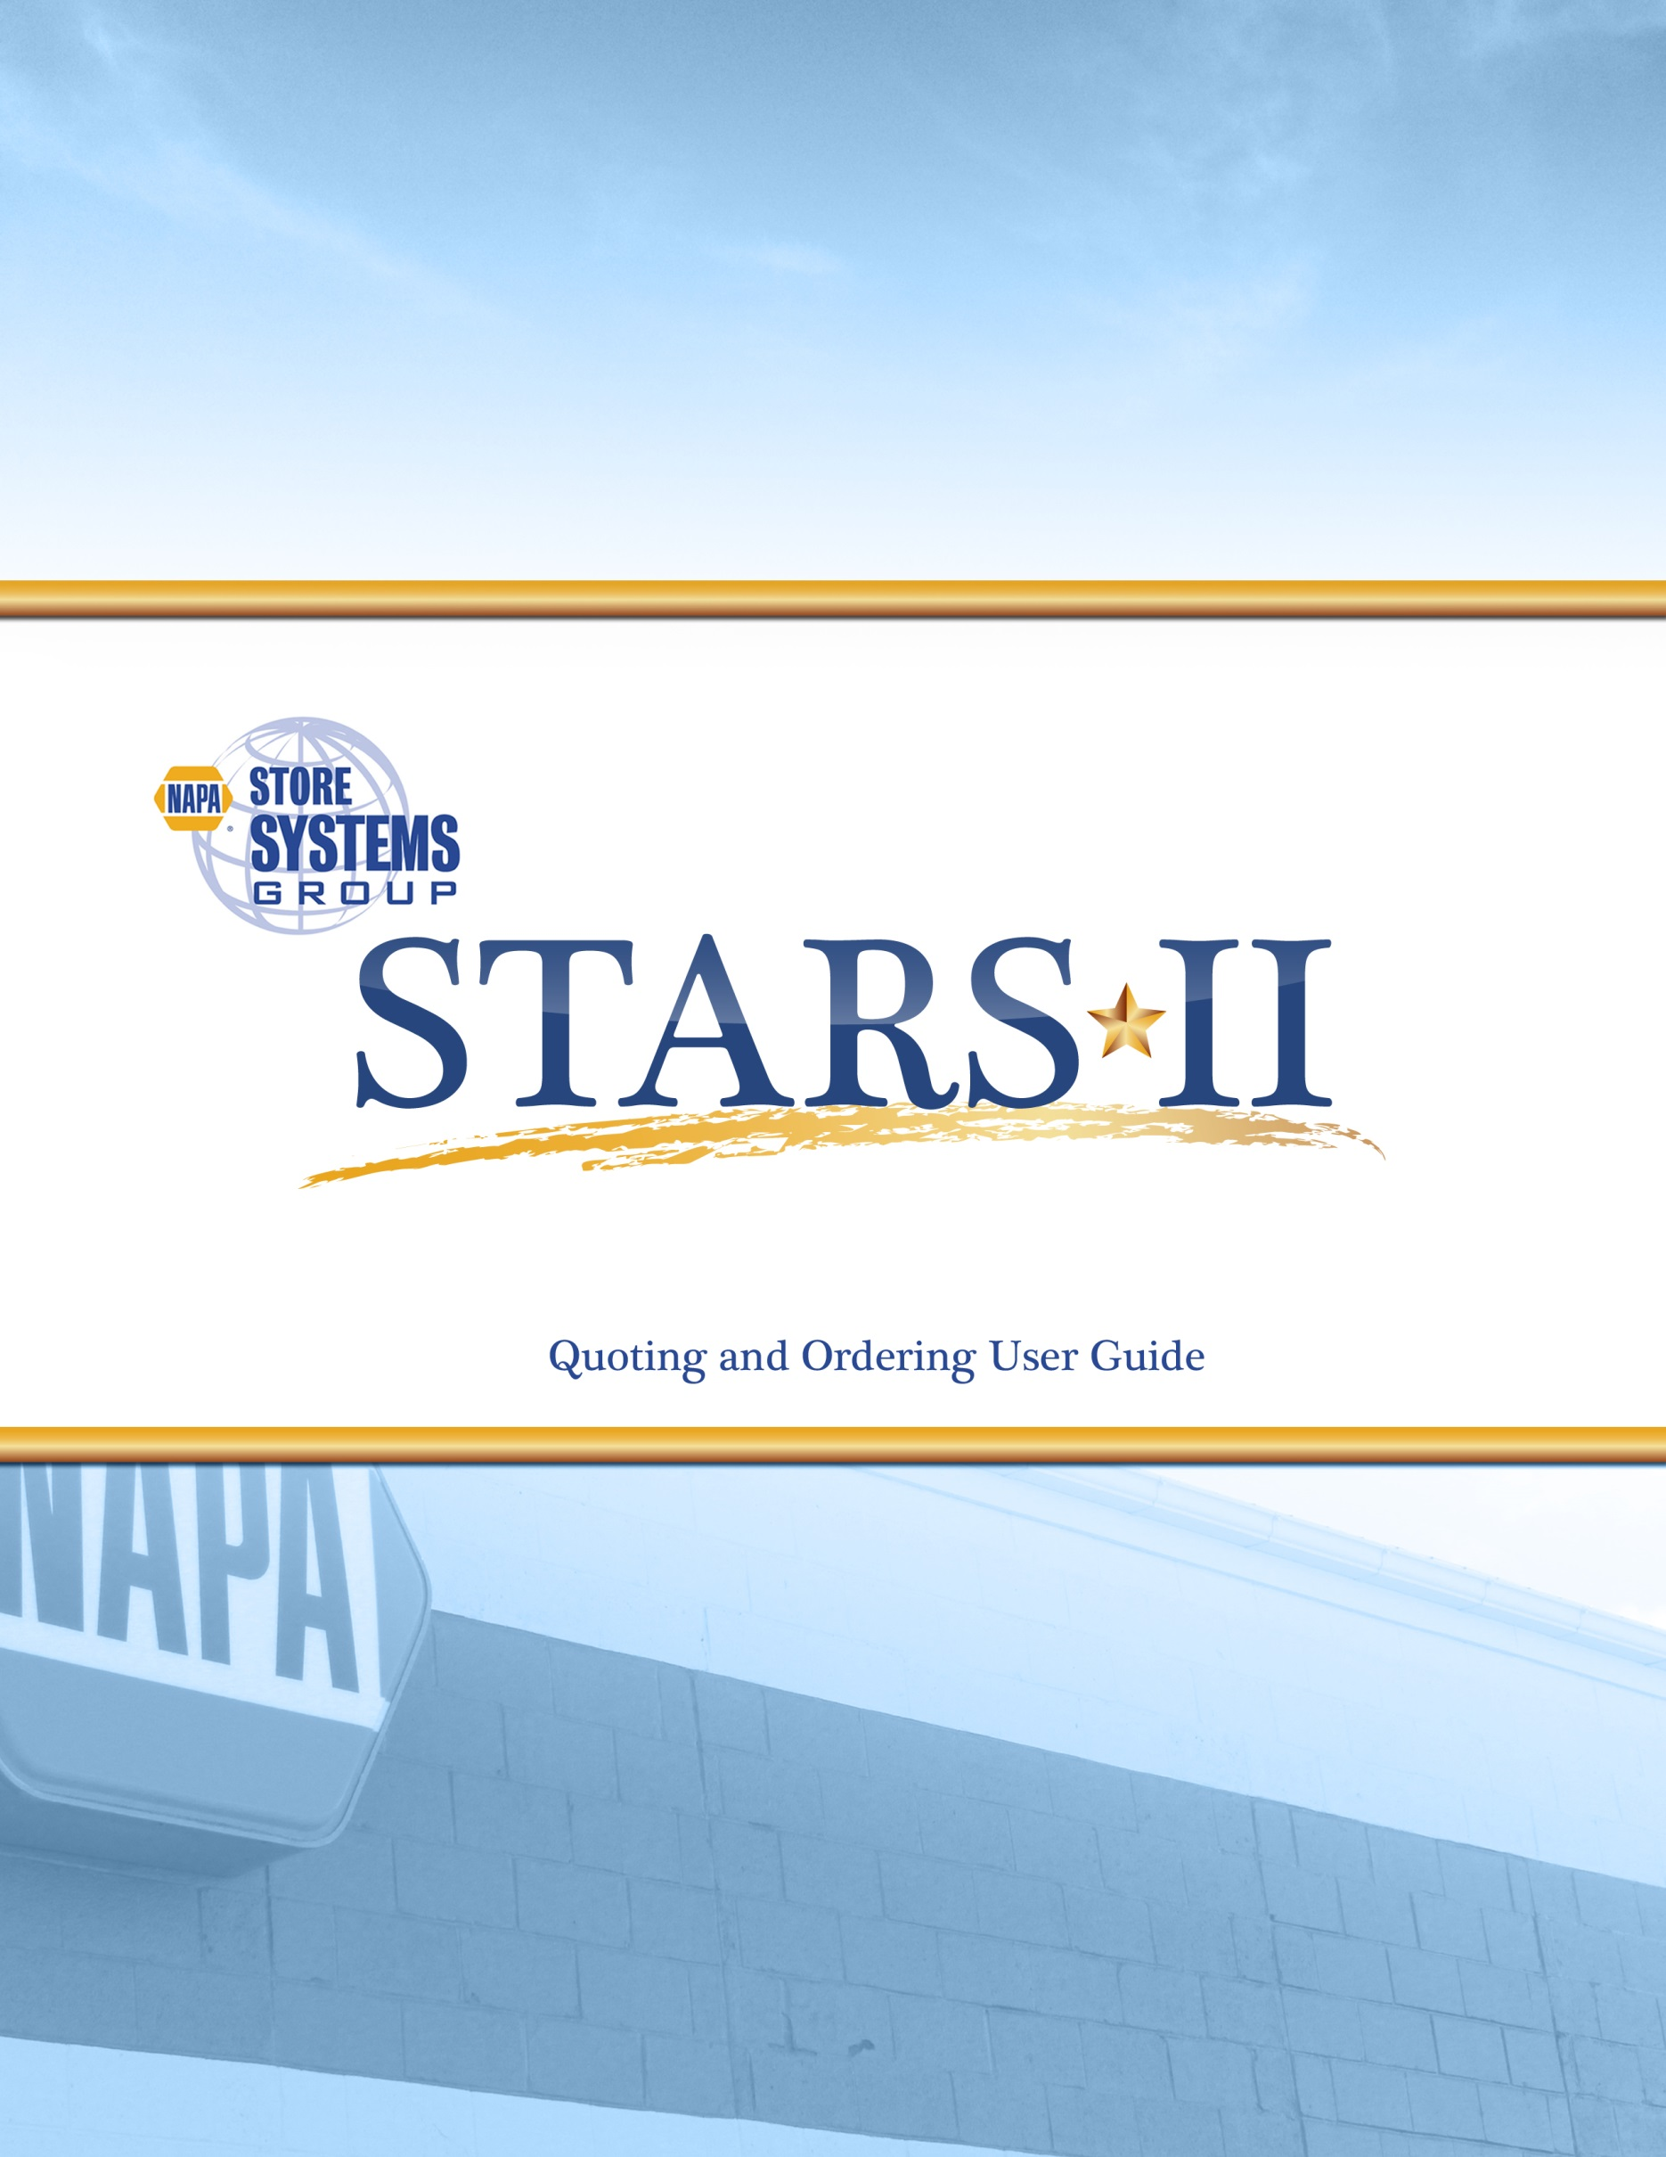
Contents
Launching the Application 2
Logging In 2
Home Tab & the Order Management Dashboard 2
Home Screen 2
Grids Overview 3
Quoting Grid 3
Leasing Grid 3
Installation / Recent Billing Grid 4
Purchasing Grid 4
Order Creation Wizard 5
Order Total Indicator 5
Step 1: Information 5
Bill To/Order By Information 5
Shipping Details 6
Installation Details 7
Step 2: Computers 7
Step 3: Accessories 8
Step 4: Services and Support 8
Step 5: Review Summary 9
Submit Quote 9
Purchasing Tab 10
Billing / Install Tab 11
Installation Recording 12
Full Installation 12
Partial Installation 13
Inventory Management 13
Available Inventory Grid 13
Creating Available Inventory (previously Excess Inventory) 14
Using Available Inventory 15
Pending and Recent Billing 15
Products Tab 15
Help 16
Logging Out 16
Contacting XL 16

Launching the Application

Logging In
- Open an internet browser and type in the web address: http://stars.mynapa.biz
- You will be presented with the Stars II login screen.
- Enter your Login Name (not case sensitive) and Password (case sensitive)
- If you would like Stars II to remember your username and password, you can check the “Remember me next time” box.
- Click “Log In” to enter the Stars II application.

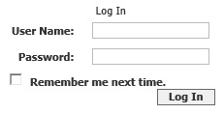

Home Tab & the Order Management Dashboard

Home Screen
The Home screen of the Stars II application is also known as the Order Management Dashboard. From here, Stars II users are given an overview of all their active orders, from the initial draft phases, to recently billed invoices.
Located at the top of the screen are a series of navigational tabs. These tabs allow users to access details about their orders as they move through the various stages of completion, as well as access product listings, reports, and customize Stars II through administrative utilities. We will explore these tabs further in the coming chapters.

Grids Overview
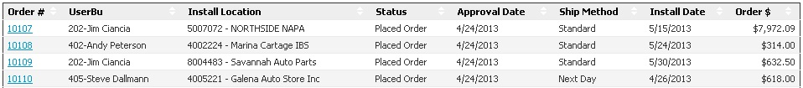
Grids are located throughout Stars II, and are used to organize orders as they move through the quoting, ordering, installation, and billing processes. Certain grids will appear in multiple places in Stars II. As an example, the Purchasing grid appears in the Home tab, Purchasing tab, and in the Billing/Install tab. This is for the convenience of the user, so that if they want to follow their orders in the fullest detail they can click on individual tabs, or if they prefer to follow their orders from a broader standpoint, they can view the entire process through the Order Management Dashboard. The following sections will describe the function of each grid, and how they organize your orders as they continually change statuses.

Quoting Grid
The quoting grid displays orders that reside in the Draft and Quote phases. Drafts are orders that have been started by a user and saved before they were completed and submitted to the customer. A Quote status indicates that the order has been fully entered and sent to a customer for approval.
Each order in the Quoting Grid can be accessed by clicking the “Order #” hyperlink to the far left of the grid. Clicking these links will open your order in the Order Creation Wizard (which is covered in detail in the next section), allowing you to edit it, and potentially submit an updated version of a quote to the customer. The grid headers indicate the order number, business unit (BU) of the SSR who created the order, the installation location, status, date the quote was created, shipping method, installation date, and order amount. The entire grid can be sorted by clicking any of these headings, as is the case with any grid found in Stars II.
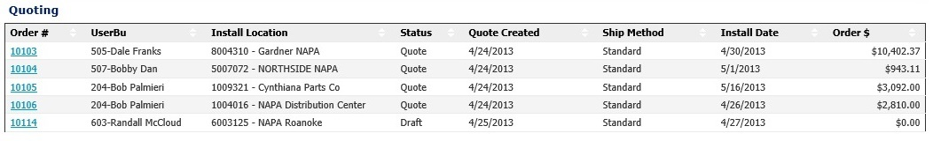

Leasing Grid
The leasing grid lists orders that have been sent to and approved by the customer, but the customer would like to lease the ordered equipment through Commodore Leasing. Orders found in this grid will have a “Pending Lease Approval” status. Once Commodore has approved the customer’s lease application, the order can continue into the next phases of completion. The leasing grid contains the same order information and sorting capabilities as the Quoting Grid.

Installation / Recent Billing Grid
The Installation / Recent Billing grid contains orders that can be found in the Install/Billing tab. At this point they have been quoted, approved, ordered, installed, and or billed, completing the ordering cycle in its entirety. Orders in this section can be accessed as an invoice for 60 days after they have been billed to the customer. After this 60 day period, orders can still be accessed via the search function by order number or store number.

Purchasing Grid
The purchasing grid contains Pending Orders and Placed Orders. The “Pending order” order status indicates that the order has been approved by the customer, but purchase orders for the products have yet to be made with the vendors supplying them. Purchase orders will be created automatically multiple times a day in batches by the NAPA Administration Manager. Once purchase orders have been created for all pending orders, the order status will change to “Placed Order”. This status indicates that the order is ready for installation at the Install Location, on the Install Date specified in the grid headings.
Depending on where the purchasing grid is accessed, users can access their orders in a variety of views. Clicking the Order # link in the purchasing grid on the order management dashboard will bring users to the order creation wizard. Click the order number link in the Billing/Install tab will open the Installation Recording screen, where SSRs record the receiving and installation details for their orders. Please read the Billing/Install Tab section of this guide for more information on how to use the Installation Recording page.
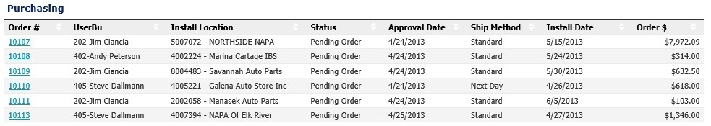
The order management dashboard is meant to give users access to their orders in all the major stages of the ordering process. While many of the same grids can be found in the Purchasing and Install/Billing tabs, the dashboard aims to allow users to view the ordering process in its entirety.

Order Creation Wizard
To begin using the Stars II application, users must start by initiating and creating a quote. This is done through the Order Creation Wizard, which is a simple 5 step process that allows users to specify billing, shipping, and installation information, as well as choose hardware, software and services for approval by the customer. To begin using the Order Creation Wizard, click the “Start a New Quote” button on the upper right corner of the Order Management Dashboard.


Order Total Indicator
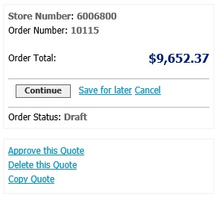
Located on the upper right of the page, the Order Total Indicator will display on every page of the Order Creation Wizard as you move through its various steps. It displays store number, order number, order total, and features buttons to Continue, Save for later, and Cancel. The Continue button will save your changes and allow the user to continue to the next page. The Save for Later link will save all changes made to the page and revert the user back to the Order Management Dashboard. The cancel button will send the user back to the dashboard without saving any changes.
Tools to Delete, and Copy the current quote are also found in this tool. Regional Managers and NAPA Admins also have the ability to approve quotes through the Order Total Indicator. Should an emergency arise where a customer needs you to approve a quote without their participation, contact a Regional Manager or your NAPA Stars II Administration Manager to utilize this feature.

Step 1: Information
The first step in creating a quote is entering the Bill To/Order By Information, Shipping Details, and Installation Details.

Bill To/Order By Information
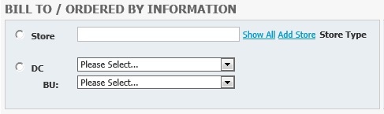
First the user needs to choose whether the order should be billed to a store or a DC via the radio buttons to the left. The store type will display to the right of the field once a store has been chosen. If a Local store or DC is chosen, the order will be priced at cost, while Jobber and COJ store types will be billed at full price. Users may begin typing a store’s name in to the provided field, and the field will auto-populate a dropdown menu of all the stores under that user’s BU. The “show all” link to the right of the store field will list all available stores. If the order is for a new store, the user can click the “add store” link, which will open the Add New Store dialogue.

Add a New Store
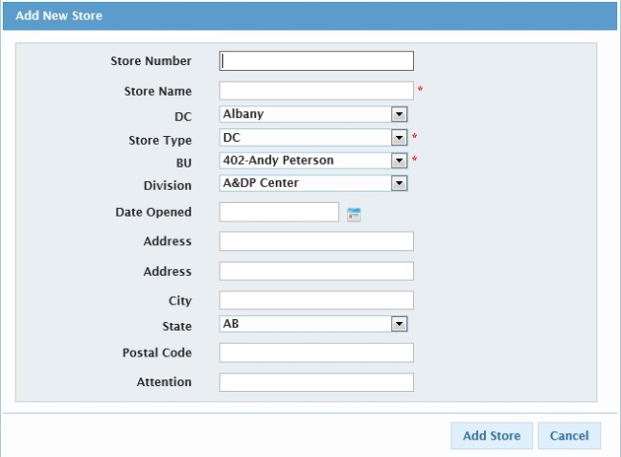
When adding a new store, the only required fields are indicated by red asterisks, although users are encouraged to provide as much information as possible when using this feature. Once the required fields are completed, click Add Store to continue. To revert to the previous screen, click the cancel button.
Back in the Bill To / Order By Information screen, users may also choose to bill the order to a DC. In this case, click the DC radio button and choose from the dropdown.
Users are required to indicate the ordering user’s BU from the dropdown before moving forward in the ordering process. This will indicate the user who will see the order on their Order Management Dashboard in Stars II. By creating an order for another SSR, you will be unable to access that order through your account since only orders under your BU will be displayed for your login.
Once a store or DC is chosen, the remaining fields on the page will auto-populate. The only required field beyond BU before continuing to Step 2 of the quoting process is the Start and End Date for planned installation, which can be found in the Installation Details section at the bottom of the screen. Inevitably the billing, shipping and installation information will all need to be provided, however the user can continue creating a draft of their quote and leave this information blank until its readily available for entry.

Shipping Details
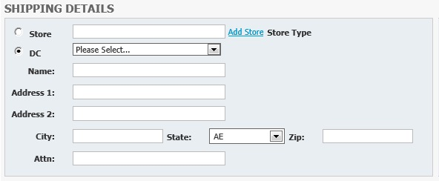
If the auto-populated shipping details in this section are correct, you may move on to the installation section. If the order needs to be shipped to a different location, you may fill out this section using the same functionality as the last one by choosing a store or DC, and filling out the contact information in the provided fields.

Installation Details
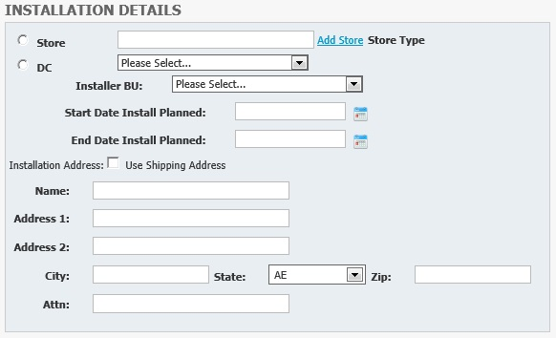
The installation details indicate where the user would like the order to ultimately be installed. Again, this field is auto-populated based on the Bill To/Order By section, and if the information is already correct the user only needs to choose a Start Date and End Date for planned installation via the indicated fields to continue. If the installation details are the same as the shipping details, the user can also click the checkbox, “Use Shipping Address” to auto-populate this section. It can also be filled out manually via the provided contact information fields.
Keep in mind, after a store is chosen in the Bill To / Order by section, a BU is chosen, and an installation date range is chosen in the Installation Details section, the user may continue past this screen to complete the other portions of the ordering wizard by clicking the continue button at the bottom of the screen. The navigational arrows at the top of the screen can also be used to navigate between sections, however changes will not be saved without clicking “continue” or “save for later”.
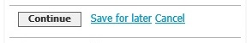
You may also use the Save for Later feature to save the order as a draft and revert to the order management dashboard, or cancel to cancel the draft entirely.

Step 2: Computers
The second step in the Order Creation Wizard prompts the user to choose computer equipment they would like to include in their quote. The top section contains servers and server accessories, and the bottom section allows users to order workstations in various configurations of their choosing. Selecting quantities for certain items in these sections will automatically include additional associated items.
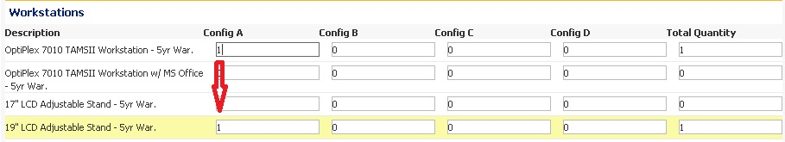
When associated items are suggested, they will highlight in yellow and a quantity will be added. They can be removed by changing the quantity in the highlighted field. (NOTE: Choosing certain equipment, like servers, can add associated items on other pages of the order creation wizard. It’s important as you’re getting acclimated to the application that you review your order thoroughly so as not to order unintended items that are associated products).
Once the intended products have been selected, the continue button will save all changes made to this page, and move you on to step 3. The save for later button will save this order as a draft and revert the user back to the order management dashboard, and the cancel button will send you back to the order management dashboard without saving your changes. The order will still appear as a draft in the quoting grid, and can be accessed later by clicking the “Order #” link.

Step 3: Accessories
Much like step 2, the third step in the order creation wizard allows users to choose accessories they would like to add to their quote. Each accessory category can be clicked to expand a list of available items, and the desired quantity can be entered into the provided fields. Once completed, the navigational tools at the bottom of the page and in the Order Total Indicator (which again are Continue, Save for later, and Cancel) will allow the user to continue to step 4.
As a reminder, the user can also navigate to different sections of the wizard via the numbered page links at the top of the page. Clicking these buttons will not retain unsaved changes made to the page the user is currently on, however you will be prompted to confirm that you would like to navigate away from the page and abandon your changes before you can leave.

Step 4: Services and Support
This section allows users to choose from a variety of services and support currently being offered to customers. It functions identically to the previous sections in allowing the selection of any quantity for an item they would like to add to their quote. Please keep in mind billable services are often times automatically suggested and added to an order as parts of a product association.
As well as labor, services, and support, Available Inventory for previous orders can also be added to orders in this section. Simply add the desired quantity for any product that’s available that you would like to use in your order. The product will not be re-ordered, but will be included at the point of Installation Recording. Available Inventory will be covered in further detail in the Inventory Management section of this user guide.

Step 5: Review Summary
The Review Summary page allows you to review and edit your quote before submitting it to the customer for approval. Any items you would like to remove from your order can be canceled via the blue X next to that item.
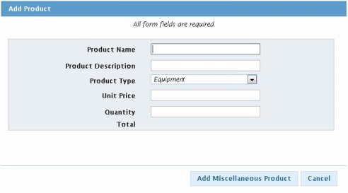
This section also allows users the opportunity to add miscellaneous items to their orders via the “Add Miscellaneous Product to Order” link at the bottom of the page. The link will open a dialogue that requires information about the product such as name, description, type, price, and quantity. Once this information has been provided, click the “Add Miscellaneous Product” button to continue. The product will now appear on your order, and can be cancelled by clicking the blue X that appears next to the product listing. Keep in mind that this feature will not automatically order and ship the miscellaneous product in question, but is available as a means to bill the customer for products that are purchased by an SSR outside of Stars II.

Submit Quote
Once you are happy with your order, click Continue. This will bring you to the final step of the ordering process where your quote is displayed for one final review before submission to the customer. Contact information for the customer will auto-populate in the provided fields, but can be edited as needed. Confirm that it is correct for the customer in question, and that you’ve chosen the appropriate shipping method. There is also a Notes field provided should users need to include any special instructions or additional information for the customer.
If the order is for a Jobber, and the customer indicated that they would like to lease the equipment in the order, users can choose Commodore Lease from the leasing section. Every order for a Jobber will automatically send notification to Commodore Leasing, and submit a lease application with your quote.
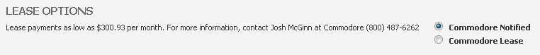

If everything looks correct and is filled in properly, click the “Submit Quote” button to submit your quote to the customer. If you need to go back and make changes to your order, click the “Back to quote” link on the bottom right of the screen.
Once your quote has been submitted, a copy will be sent to the customer’s email address that was indicated in the contact information, and they will be able to approve the quote via a button in that email. When a quote is approved, it will be automatically moved from the quoting section in the order management dashboard to either the purchasing section, or leasing section if Commodore Lease was selected.
Even after a quote is submitted, it can still be opened, modified, and additional quotes can be sent to the customer if they decide not to approve the first one. Once a customer approves a quote and it becomes a pending order, it can no longer be edited in quantity or content by the SSR, with the exception of miscellaneous products being added on site during Installation Recording (see the Billing/Install tab section of this guide for more information). Quotes will expire 30 days after they were first submitted to the customer if they are not approved.

Purchasing Tab
This tab allows Stars II users to follow their orders through the purchase ordering process, and if they so choose, access the Installation Recording Page via the Purchasing Grid.
When a quote is approved by a customer, it changes status from “Quote” to “Pending Order”. At this point a purchase order needs to be created and sent to the various vendors that supply equipment for the order. Since multiple quotes are approved daily by customers, for the sake of efficiency the NAPA Administration Manager only creates purchase orders twice a day by clicking the “Create All Purchase Orders” button located at the top of the screen under the Pending Orders grid.
If you open an order in the Billing/Install tab or Purchasing tab and there are no available quantities to be installed, this indicates that the order is still in “Pending Order” status, and has yet to have purchase orders created for it.
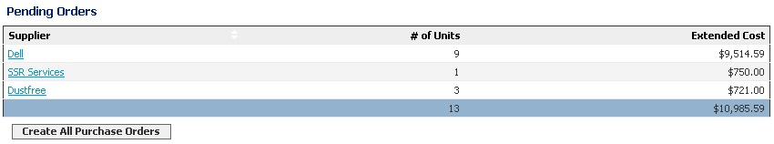
Once all purchase orders have been created, SSRs will notice that the status of their orders has changed from “Pending Order” to “Placed Order” in the purchasing grid. This indicates that the order has been placed with the vendor, and can be expected to arrive at the ship to location indicated in your original quote to the customer.
Similarly, in the Current Open Purchase Orders grid, users can click on the various vendor links for their specific orders to view information about that order, such as shipping and billing addresses, installation date, and equipment information.
In the following grid labeled Future Dated Purchase Orders, users can see upcoming purchase orders that will be made once the installation date approaches.
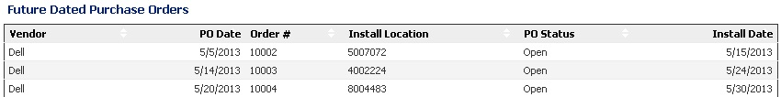
Also found on the purchasing tab is the Available Inventory grid. This contains all pieces of available inventory from previous orders under an SSRs given BU. This grid will be covered in more detail in the Inventory Management section of this user guide.
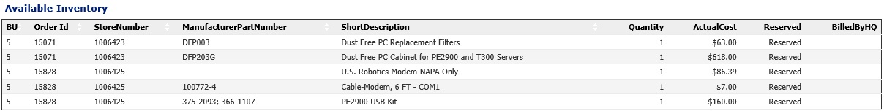
From the perspective of the SSR, the Purchasing Tab’s purpose is to give visibility to their order after it’s been approved by the customer, and before they go to the installation location to physically perform and record the installation.
Users may also notice that the Purchasing grid found on the Order Management Dashboard also appears in the Purchasing tab. Once a purchase order has been created with the vendor, clicking on Order # links in this grid will bring users to the Installation Recording page, which is explained in detail in the following section.

Billing / Install Tab
This section of Stars II allows users to complete their orders by installing products and services, performing their Installation Recording, and billing the customer. The tab should look very familiar at this point, containing grids for Purchasing, Pending Billing, and Recent Billing.
The Purchasing grid on this tab is identical to the others found elsewhere in Stars II, with the exception that clicking order links from here will bring users to the Installation Recording page. By clicking the Order # link for Placed Orders, SSRs can record their installations, and prepare an order to be billed to the customer.
Orders with a Pending Order status found in this section will bring you to the Installation Recording Page as well, however the Installation Recording cannot be conducted until purchase orders for the quoted equipment and services have been created by the NAPA Administration Manager. This happens twice daily and typically occurs once in the morning and once in the afternoon. Should an emergency arise that requires purchase orders are created immediately, please contact your NAPA Administration Manager, or the NAPA helpdesk (contact information is found in the Help link on the upper right corner of your screen).

Installation Recording

Full Installation
When an order is opened in the Installation Recording screen, all pertinent information from the original quote is located at the top of the screen, followed by a list of all the items in your order. If at any point you would like to save your changes, or return to the Billing / Install tab, you can do so by using the links found at the bottom of the page.
Should any miscellaneous items need to be added to the order on the site of installation, click the “Add Miscellaneous Product to Order” hyperlink. This feature functions identically to the miscellaneous product feature found in the Review Summary page of the quoting process. Again, this feature is used to bill customers for products purchased outside of Stars II, and will not order or ship the products that are entered.
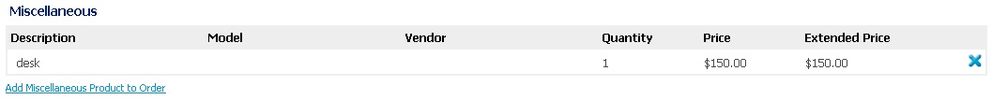
To begin your Installation Recording, fill in the Received Quantity field for the items that arrived as expected for installation. Once the item is installed, fill out the Quantity Installed field and the Service Tag field if any are required. Certain products may require multiple service tags. Click the “insert” link when you have finished entering each tag to record it in the order.
Once these fields are completed, the price will calculate a grand total to be billed to the customer. Fill in the Actual Installation Date field, and Actual Installer BU to indicate the SSR that performed the installation (Note: these fields are required to bill any portion of the order). If you are happy with your Installation Recording, you may click the “Install Complete – OK to Bill” button located at the bottom of the page, and the order will move to the Pending Billing grid in the Billing/Install tab to await invoicing by the NAPA Administration Manager.

Partial Installation
Sometimes an SSR may need to only install part of an order without completing and closing it. Stars II allows for this via the Partial Install button found at the bottom of the Installation Recording screen.
To partially install an order, fill in the received and installed quantities as indicated above. Clicking “Partial Install” will create an invoice in the Pending Billing grid only for the parts of the order that were received and installed. The order will remain in the Purchasing grid with invoices created for partially installed portions of the order until the SSR clicks “Install Complete – OK to bill”. When the order is re-opened in the Installation Recording Page after a partial installation, the quantity fields for previously installed items will be read-only.

Inventory Management
Often times an SSR may find themselves in a position where they don’t need a piece of equipment that’s part of an order, or that they would like to use inventory found in one order in a new order. Stars II has a feature called Available Inventory which allows the SSR to control the movement of inventory between existing orders and new orders, and even between different user’s BUs.

Available Inventory Grid
Located at the bottom of the Purchasing tab, the Available Inventory grid contains all available inventory from previous orders that an SSR has under their BU.
Information like BU, Original Order ID, Original Store Number, and Product Description can help the SSR identify exactly where a piece of available inventory originally came from. If a piece of available inventory is “reserved”, it has already been made part of another order and will not be displayed in the available inventory section of the Order Creation Wizard for usage.

Creating Available Inventory (previously Excess Inventory)
If items in an order were received at the install location, but the customer for some reason no longer wants them installed, they can be placed in the user’s available inventory by entering the received quantity, leaving the installed quantity at zero, and clicking the “Installation Complete – OK to Bill” button. The user will be prompted to confirm that they wish to close the order and move any additional existing inventory to their Available Inventory. Click the confirmation button to finish installing the order. Any extra inventory will then be displayed in the Available Inventory grid at the bottom of the Purchasing tab, and will be available to fulfill other orders via the Available Inventory section on page 4: Services and Support section of the Order Creation Wizard.
Another feature on the Installation Recording page that allows users to manage their available inventory is the “Move to Available Inventory” button. This feature allows the user to move pieces of an order to their available inventory, without actually installing and closing the rest of the order.
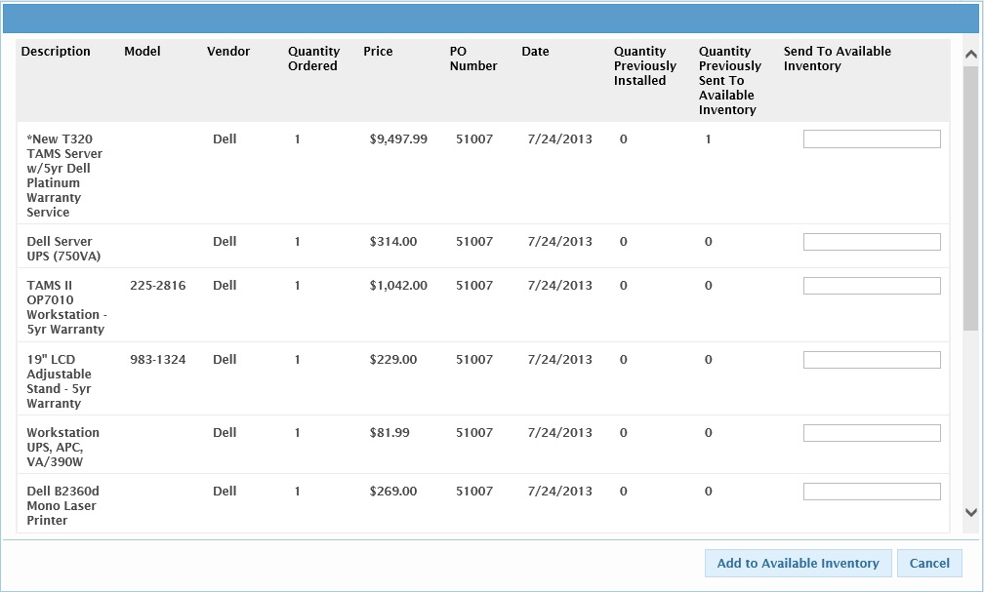
Once the button is clicked, a dialogue will open which displays all products found in that order. To move a product to Available Inventory, simply add the quantity you would like to move (making sure it does not exceed the quantity ordered), and click “Add to Available Inventory”. The product will now be available via your Available Inventory grid, and will be marked as “Previously Sent to Available Inventory” on your installation recording page. Be aware that this product can no longer be included as a part of the original order once it is removed. For example, if a quantity of two of the same products was ordered, and one was moved to available inventory, only the remaining product would be able to be installed as part of the original order.

Using Available Inventory
To use available inventory, start a new quote, or open an existing quote. As it has previously been mentioned in this user guide, available inventory can be accessed at the bottom of Page 4: Services and Support, of the Order Creation Wizard. Simply select the quantity of any product you would like to include, and continue the quoting process as you normally would. Any available inventory added to an order will be automatically installed during Installation Recording.
The ability to move pieces of available inventory to use in another order has a variety of applications and was designed to give the SSR the flexibility to move product, trade products between BUs by creating orders for other SSRs, and change billings of existing orders by creating new quotes using available inventory. This tool has a variety of functions, and should be utilized to manage many of the administrative changes that used to be conducted by your NAPA Administration Manager.

Pending and Recent Billing
When an order has been installed or partially installed, the installed components are exported as an invoice to the Pending Billing grid on the Install/Billing tab. This grid acts as a receptacle for the invoices until they’re ready to be sent to NAPA headquarters in batches, and then distributed to the customers. Once the “Bill All Invoices” button is clicked by the NAPA Administration Manager, invoices will be sent to their respective recipients, and copies of the invoices will be moved to the Recent Billing grid (found both in the Install/Billing tab as well as the Home Tab).
This grid provides one final opportunity for Stars II users to view invoices for their orders before they’re archived for reporting. The invoices can be activated by clicking the Invoice ID link to the left of the grid. Within each invoice there is a list of associated invoices, which are all the invoices for items contained within an order. The invoices will be held in the Recent Billing grid for 60 days.

Products Tab
The products tab allows users to list and sort all the equipment and services currently offered in Stars II. Each product detail displays a product number, image, model number, price, description, and warranty information. To the far left is a sorting section by brand and product type. Clicking on any of the vendor names or categories will display only the products in that particular selection.
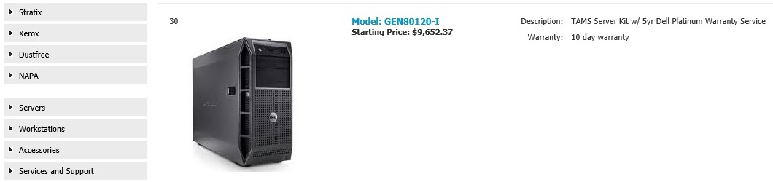

Help
The Help section can be found on the upper right corner of any page in Stars II, next to the Log Out button. It contains all the forms previously contained in the Macropack, as well as this user guide, and contact information for the NAPA Help Desk.

Logging Out
If you are using your NAPA Sales Planning tool on a public computer you should log out when you are finished. To log out click the ‘Log Out’ link located above the main navigation tabs.

Contacting XL
The NAPA Help Desk is available to help you if you need assistance accessing the application, if you have questions about features or reports, or if you experience any difficulty while using the website.
NAPA Help Desk Contact Information:
- Phone: 1-800-309-9000
- Email: helpdesk@mynapa.biz
- Mailing Address:
XL Group, Inc.
Attn: NSP Help Desk
121 Doyle Street
Doylestown, PA 18901

